**Laporan 3 - Akuisisi Data Penelitian**

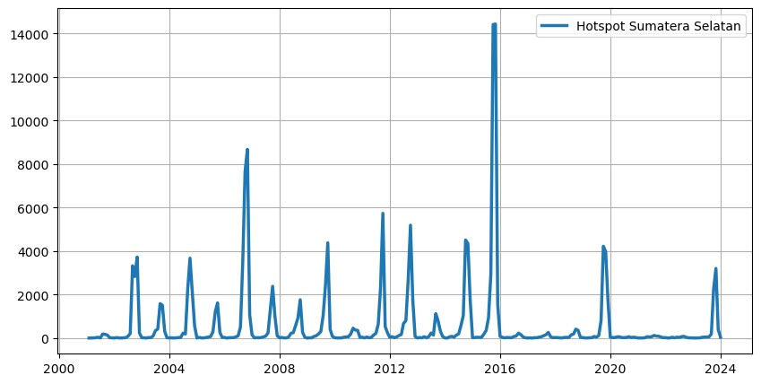

Gambar 1. Hotspot Sumatera Selatan tahun 2001 – 2023

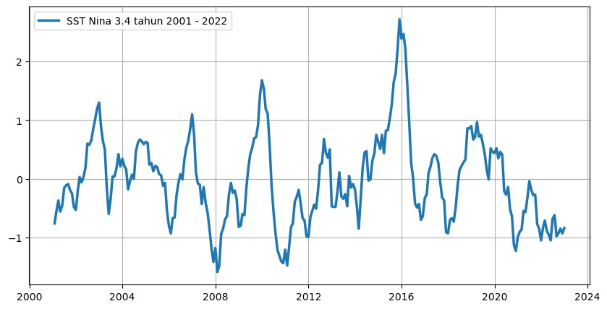

Gambar 2. SST Nino 3.4 tahun 2001 – 2023

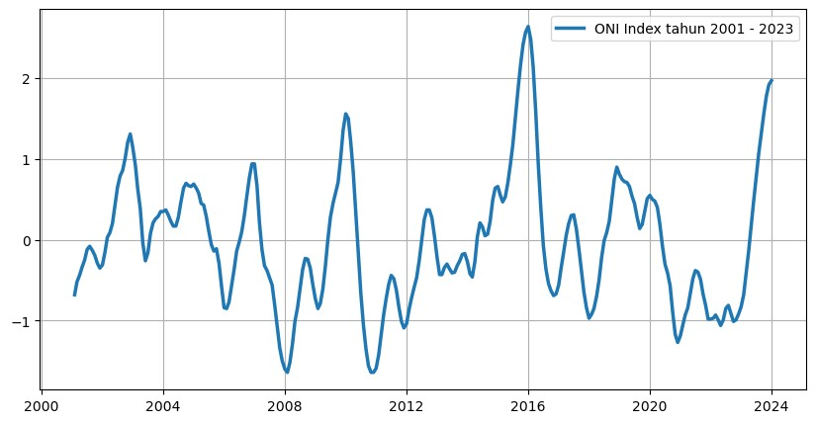

Gambar 3. ONI Index tahun 2001 – 2023

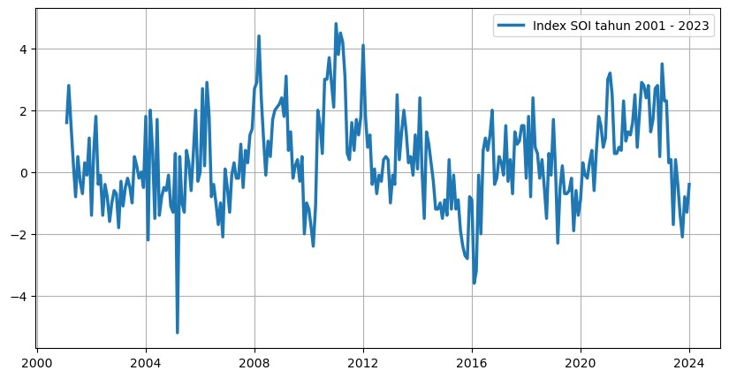

Gambar 4. SOI Index tahun 2001 – 2023

Metadata dataset

|  |  |
| --- | --- |
| Types of datasets | Description |
| Hotspot |  |
| Temporal resolution | Daily, January 1st, 2001 to December 31st, 2023. |
| Satellite | Terra-Aqua |
| Sensors | Moderate-resolution Imaging Spectroradiometer (MODIS) |
| Providers | Fire Information for Resource Management System The National Aeronautics and Space Administration (FIRMS) |
| Attributes | latitude, longitude, brightness, scan, track, acq_date, acq_time, satellite, instrument, confidence, version, bright_t31, frp, daynight, type |
| Data format | csv |
| Source | <https://firms.modaps.eosdis.nasa.gov/download> |
| SST Nino 3.4 |  |
| Temporal resolution | Monthly |
| Providers | National Oceanic and Atmospheric Administration (NOAA) |
| Attributes | year, mon, nino1+2, anom 1+2, nino3, anom3, nino4, anom4, nino3.4, anom3.4 |
| Data format | csv |
| Source | <https://www.cpc.ncep.noaa.gov/data/indices/sstoi.indices> |
| Index SOI |  |
| Temporal resolution | Monthly, January 2001 to December 2023. |
| Providers | National Oceanic and Atmospheric Administration (NOAA) |
| Attributes | year, jan, feb, mar, apr, may, jun, jul, ags, sep, oct, nov, des |
| Data format | csv |
| Source | <https://www.cpc.ncep.noaa.gov/data/indices/soi> |
| Index ONI |  |
| Temporal resolution | Monthly, January 2001 to December 20203 |
| Providers | National Oceanic and Atmospheric Administration (NOAA) |
| Attributes | ses, year, total, anom |
| Data format | csv |
| Source | https://www.cpc.ncep.noaa.gov/data/indices/oni.ascii.txt |